**Experiment: 3.3**

Student Name: Vivek UID:

Branch: CSE Section/Group: Semester: 3rd Date of Performance:03-11-2022 Subject Name: Database Management System

Subject Code:21-CHS-14

1. **Aim/Overview of the practical:**

Introduction and implementation of programs of Triggers.

1. **S/W Requirement:** Oracle Database 11g Express Edition or Oracle Live Sql.

# DBMS script and output:

* 1. **Before insert Trigger :**

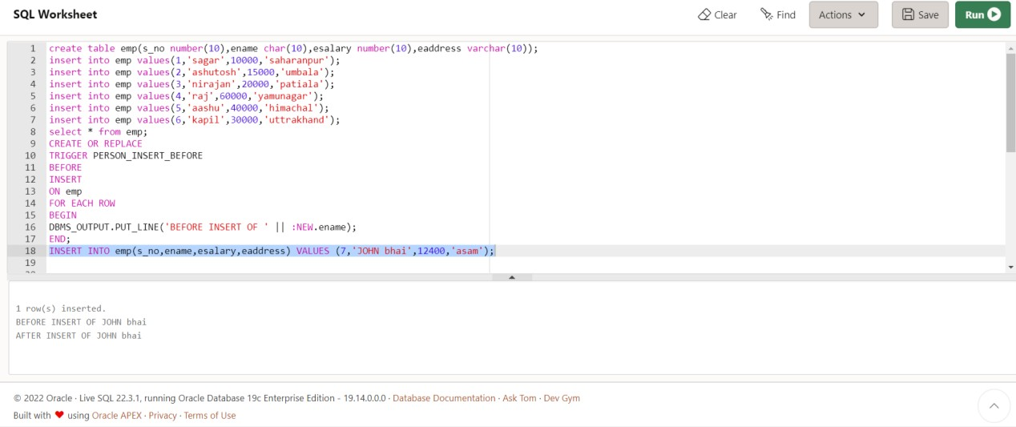

* 1. **After Insert Trigger:-**

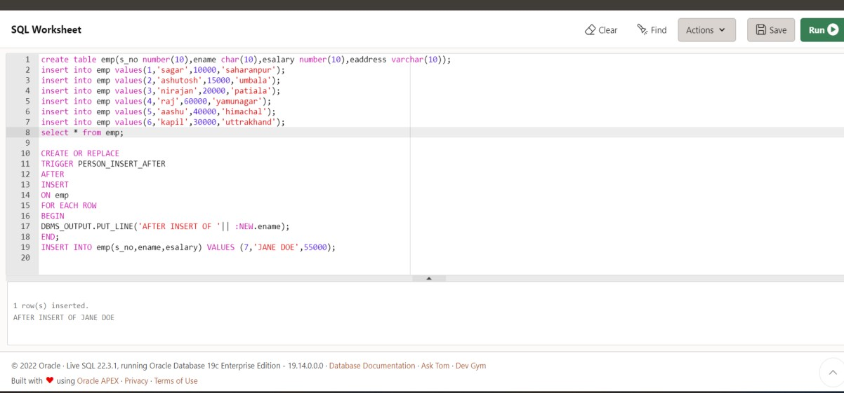

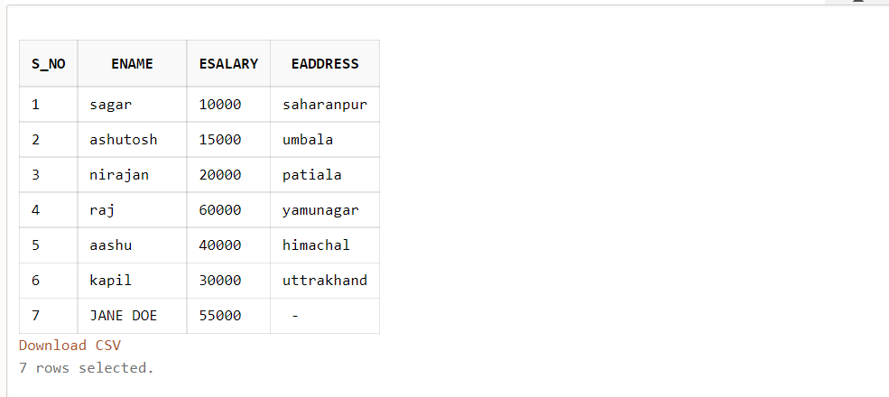

# Dropping Trigger

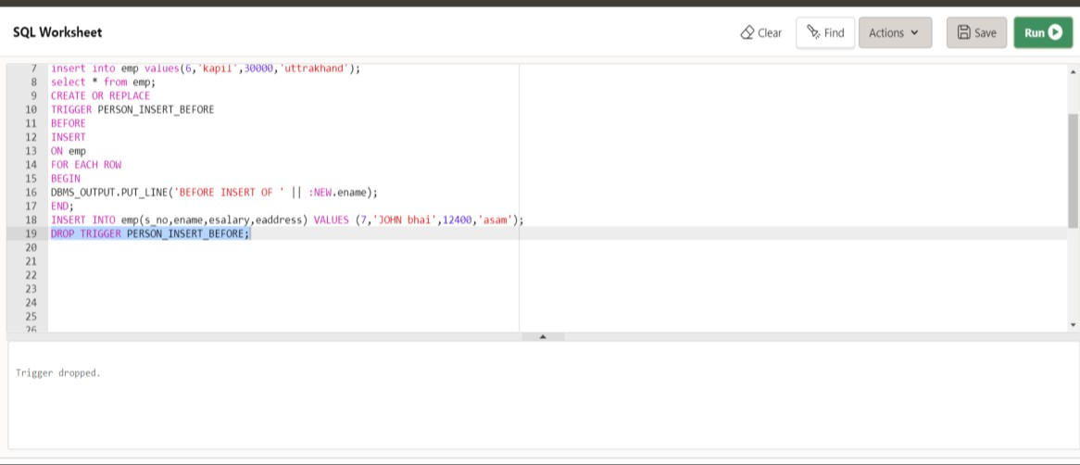

* 1. **Altering Trigger**

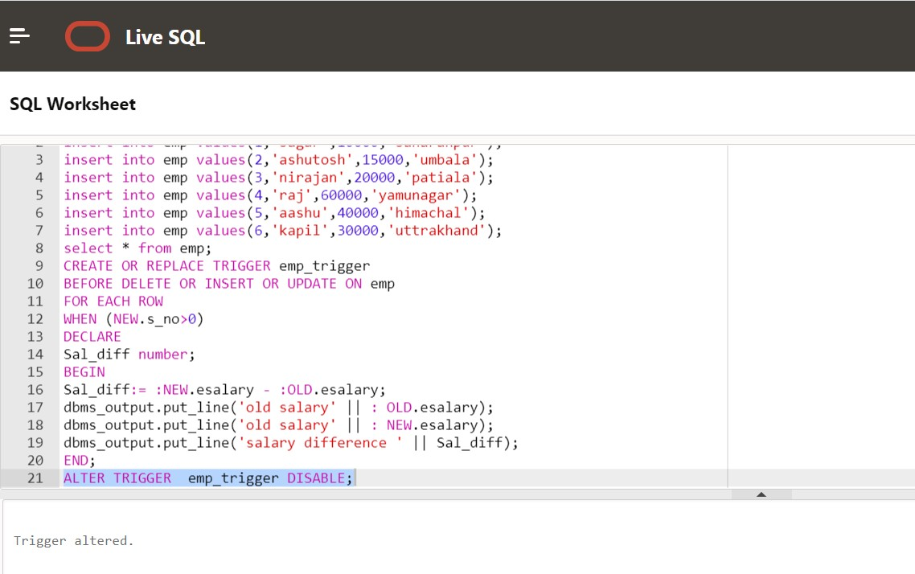

# Trigger Exception

